TESTING 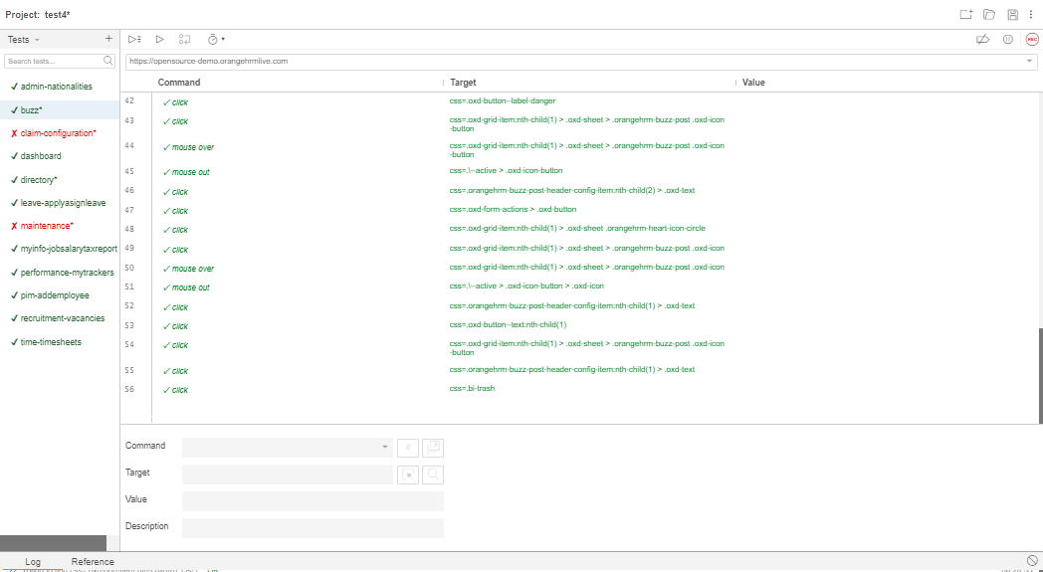

TESTING ADMIN NATIONALITIES SUBMENU

# Generated by Selenium IDE

import pytest

import time

import json

from selenium import webdriver

from selenium.webdriver.common.by import By

from selenium.webdriver.common.action_chains import ActionChains

from selenium.webdriver.support import expected_conditions

from selenium.webdriver.support.wait import WebDriverWait

from selenium.webdriver.common.keys import Keys

from selenium.webdriver.common.desired_capabilities import DesiredCapabilities

​

class TestAdminnationalities():

 def setup_method(self, method):

   self.driver = webdriver.Chrome()

   self.vars = {}

 def teardown_method(self, method):

   self.driver.quit()

 def test_adminnationalities(self):

   self.driver.get("https://opensource-demo.orangehrmlive.com/web/index.php/dashboard/index")

   self.driver.set_window_size(1056, 608)

   element = self.driver.find_element(By.CSS_SELECTOR, ".oxd-main-menu-item-wrapper:nth-child(1) .oxd-text")

   actions = ActionChains(self.driver)

   actions.move_to_element(element).perform()

   self.driver.find_element(By.CSS_SELECTOR, ".oxd-main-menu-item-wrapper:nth-child(1) .oxd-text").click()

   element = self.driver.find_element(By.CSS_SELECTOR, "body")

   actions = ActionChains(self.driver)

   actions.move_to_element(element, 0, 0).perform()

   self.driver.find_element(By.LINK_TEXT, "Nationalities").click()

   self.driver.find_element(By.CSS_SELECTOR, ".oxd-button").click()

   self.driver.find_element(By.CSS_SELECTOR, ".oxd-button--ghost").click()

   self.driver.find_element(By.CSS_SELECTOR, ".oxd-button").click()

   self.driver.find_element(By.CSS_SELECTOR, ".oxd-input--focus").click()

   self.driver.find_element(By.CSS_SELECTOR, ".oxd-input--focus").send_keys("Aaaan")

   self.driver.find_element(By.CSS_SELECTOR, ".oxd-button--secondary").click()

   element = self.driver.find_element(By.CSS_SELECTOR, ".oxd-button--secondary")

   actions = ActionChains(self.driver)

   actions.move_to_element(element).perform()

   element = self.driver.find_element(By.CSS_SELECTOR, "body")

   actions = ActionChains(self.driver)

   actions.move_to_element(element, 0, 0).perform()

   self.driver.find_element(By.CSS_SELECTOR, ".oxd-table-header-cell .oxd-icon").click()

   self.driver.find_element(By.CSS_SELECTOR, ".oxd-table-header-cell .oxd-icon").click()

   self.driver.find_element(By.CSS_SELECTOR, ".oxd-table-card:nth-child(1) .oxd-table-card-cell-checkbox .oxd-icon").click()

   self.driver.find_element(By.CSS_SELECTOR, ".oxd-table-card:nth-child(1) .oxd-icon-button:nth-child(2) > .oxd-icon").click()

   self.driver.find_element(By.CSS_SELECTOR, ".oxd-button--ghost").click()

   self.driver.find_element(By.CSS_SELECTOR, ".oxd-table-card:nth-child(1) .oxd-icon-button:nth-child(2) > .oxd-icon").click()

   self.driver.find_element(By.CSS_SELECTOR, ".oxd-input--focus").click()

   self.driver.find_element(By.CSS_SELECTOR, ".oxd-input--focus").send_keys("Aaaaan")

   self.driver.find_element(By.CSS_SELECTOR, ".oxd-button--secondary").click()

   element = self.driver.find_element(By.CSS_SELECTOR, ".oxd-button--secondary")

   actions = ActionChains(self.driver)

   actions.move_to_element(element).perform()

   element = self.driver.find_element(By.CSS_SELECTOR, "body")

   actions = ActionChains(self.driver)

   actions.move_to_element(element, 0, 0).perform()

   self.driver.find_element(By.CSS_SELECTOR, ".oxd-table-card:nth-child(1) .oxd-table-card-cell-checkbox .oxd-icon").click()

   self.driver.find_element(By.CSS_SELECTOR, ".oxd-table-card:nth-child(1) .oxd-icon-button:nth-child(1)").click()

   element = self.driver.find_element(By.CSS_SELECTOR, ".oxd-table-card:nth-child(1) .oxd-icon-button:nth-child(1)")

   actions = ActionChains(self.driver)

   actions.move_to_element(element).perform()

   element = self.driver.find_element(By.CSS_SELECTOR, "body")

   actions = ActionChains(self.driver)

   actions.move_to_element(element, 0, 0).perform()

   self.driver.find_element(By.CSS_SELECTOR, ".oxd-button--text").click()

   self.driver.find_element(By.CSS_SELECTOR, ".oxd-table-card:nth-child(1) .oxd-icon-button:nth-child(1) > .oxd-icon").click()

   element = self.driver.find_element(By.CSS_SELECTOR, ".oxd-table-card:nth-child(1) .oxd-icon-button:nth-child(1) > .oxd-icon")

   actions = ActionChains(self.driver)

   actions.move_to_element(element).perform()

   element = self.driver.find_element(By.CSS_SELECTOR, "body")

   actions = ActionChains(self.driver)

   actions.move_to_element(element, 0, 0).perform()

   self.driver.find_element(By.CSS_SELECTOR, ".orangehrm-button-margin > .oxd-icon").click()

​